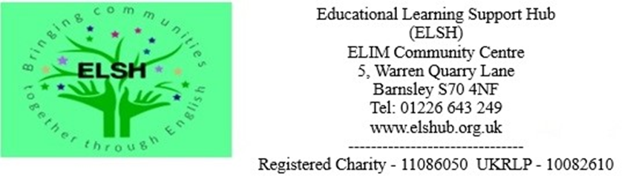

Job Description
Job Title: Trustee
Salary: Voluntary - Travel Expenses Will Be Paid
Hours: Approximately 3 Days Per Month Including Board Quarterly General Meetings & Working Party Meetings
Holidays: Not Applicable
Contract: 2 Year Term – Potentially Longer If Re-Appointed
Reporting To: Chair
Location: ELIM Community Centre, 5 Warren Quarry Lane, Barnsley, S70 4NF

Job Summary
The role of the Trustee Board is to receive assets from donors, safeguard them and apply them to the charitable purposes of ELSH. The Trustee board must always act in the best interests of ELSH, exercising the same standard of duty of care that a prudent person would apply if looking after the affairs of someone for whom they have responsibility. The trustee must act as part of a Board of Trustees and not as individuals.

About ELSH
ELSH was formed to promote social inclusion for the public benefit among people who are socially excluded on the grounds of their social and economic position. In particular, but not limited to young parents, young people not engaged in further education, employment or training, migrant workers, and asylum seekers, by providing educational support and functional skills and drop-in support to develop and gain new skills and confidence. ELSH provides education and training in the English language and in vocational skills in addition to social and recreational facilities and events involving the local community. It provides a safe and secure environment for all those engaging with the services available through the core values of empowerment, welcoming, diversity, inclusion, collaboration, advocacy, and student centered. ELSH provide free Entry 1, 2 and 3 ESOL (English to Speakers of Other Languages) in addition to basic Maths and IT skills. ELSH also provides access to valuable resources for the local refugee and migrant community to help secure not only settlement in the UK where required, but also housing and advice on how to find employment or further education.

Main Duties
- Ensure that ELSH complies with its governing document (its Articles of Association), and charity law and any other relevant legislation or regulations.
- Ensure that ELSH pursues its objects as defined in its governing document
- Ensure ELSH applies its resources exclusively in pursuance of its objects. For example, it must not spend money on activities which are not included in the objects, however worthwhile they may be.
- Contribute actively to the Board of Trustees by giving firm strategic direction to ELSH, setting overall policy, defining goals, setting targets, and evaluating performance against agreed targets.
- Safeguard the good reputation and values of ELSH
- Ensure the financial stability of ELSH.
- Trustees share ultimate responsibility for governing a charity and directing how it is managed and run.
In addition to the above statutory duties, each trustee should use any specific skills, knowledge or experience they hold to help the Board of Trustees reach sound decisions. This may involve leading discussions, identifying key issues, providing advice and guidance on new initiatives, and evaluating or offering advice on other areas in which the Trustee has expertise.

Skills Required
- A commitment to the mission and Vison of ELSH.
- A willingness to meet the minimum time requirement.
- Integrity.
- Strategic vision.
- Good, independent judgement.
- An ability to think creatively.
- A Willingness to speak their mind.
- An understanding and acceptance of the legal duties, responsibilities, and liabilities of trusteeship.
- An ability to work effectively as a member of a team and to take decisions for the good of ELSH.
The Board of Trustees collectively needs skills and experience in the following areas:
- Financial management, income generation and enterprise.
- Digital strategy and transformation.
- Human resource management.
- Information Technology and Data Protection.
- Funding / foundations.
- Collaborative partnerships.
- Social investment and impact.

What Will You Get Out of Working With ELSH?
This is an exciting opportunity for an incoming Trustee to grow ELSH in a sustainable manner and to identify and work on new projects that help to remove barriers to education for asylum seekers, refugees, and migrants across Barnsley. This is a chance to use your skills to make a direct impact to the lives of these vulnerable people.

Equality & Diversity Statement
At ELSH, we are all different, but that’s our strength and wealth. Through our shared values we create an environment where everyone feels safe in their authentic self without regard to race, colour, religion, gender, gender identity or expression, sexual orientation, national origin, disability, age, or immigration status. Together we realise our full potential and ultimate goal.

How To Apply
- Send in CV and a short letter on why you would like to get involved to florentine@elshub.org.uk,
- One of the Trustees will then arrange a virtual meeting with you or a telephone call if preferred
- The next stage would a panel interview with the CEO and 2 other Trustees, after which you will be notified about whether your application has been successful.
- Trustees are normally elected for two years initially and are free to resign at any time provided there will be a minimum of three trustees remaining.

